# **Suicide Rates Overview 1985 to 2016**

**Team Innovage**

**Tabitha Kariuki**

**Gozzo Evrard Ded**

**Wilkister Mbaka**

**Kevin Kirui**

**Moureen Mungai**

# Introduction

*Disclaimer;This report does not provide advice of any kind. The contents are for informational purposes only and is not intended to be a substitute for professional medical or mental health advice, diagnosis, or treatment.*

Suicide is death caused by injuring oneself with the intent to die. A suicide attempt is when someone harms themselves with any intent to end their life, but they may not die as a result of their actions.

Suicide is preventable and everyone has a role to play to save lives and create healthy and strong individuals, families, and communities.

Being connected to family and community support and having easy access to health care can decrease suicidal thoughts and behaviors. Suicide is preventable and everyone has a role to play to save lives and create healthy and strong individuals, families, and communities. Suicide prevention requires a comprehensive public health approach.

Recent statistics shown below. Case study of the United states;

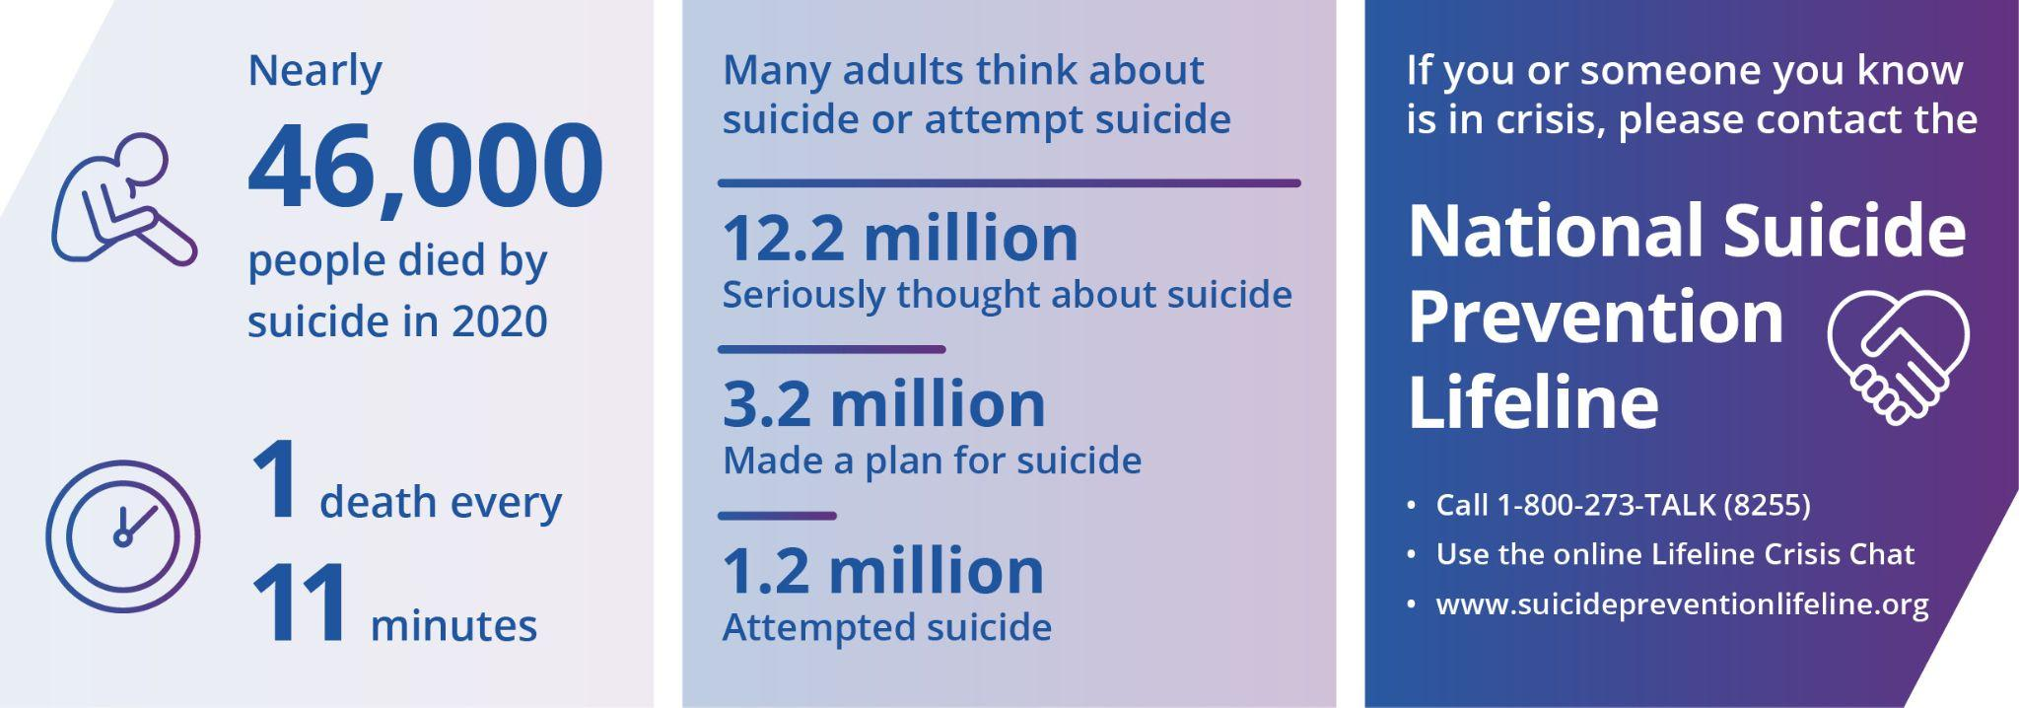

# Problem Statement

The financial toll of suicide on society is also costly. In 2019, suicide and nonfatal self-harm cost the United states nearly $490 billion in medical costs, work loss costs, value of statistical life, and quality of life costs.

Our aim for this study is to show suicide trends from the year 1985 to 2016 and support the agenda of suicide prevention across all divides.

# General Objective

The main objective of the project is to find the country with the highest suicide over the years from 1985 to 2016 and finding factors that affect suicide rates among different countries globally, across the socio-economic spectrum.

# Specific Objectives

1. To determine the suicide rates by generation
2. To determine the suicide rates by region and sub-region.
3. To determine the age with the highest suicide rate.
4. To determine the suicide rates by gender
5. To determine the year with the most reported suicides and which top countries contributed most to that number.
6. To determine the correlation between GDP per capita and suicide rates.
7. To determine the countries with the highest and lowest suicide rates from 1985 to 2016.

# Data Source

This dataset comprises of socio-economic information with suicide rates by year and country. We sourced the data from Kaggle. The dataset can be accessed here in this [Link](https://www.kaggle.com/datasets/russellyates88/suicide-rates-overview-1985-to-2016).

It has 12 columns and 27820 rows

The data is from different countries in the world

* The columns are as follows**:**

1. country
2. year
3. sex
4. age
5. suicides_no
6. population
7. suicides/100k pop
8. country-year
9. HDI for year
10. gdp_for_year ($)
11. gdp_per_capita ($)
12. generation

# Hypothesis

Hypothesis Test

**Ho** : Generation X's suicide rates are equal to the average suicide rates of Boomers.

**Ha** : Generation X's suicide rates are not equal to the average suicide rates of Boomers.

We reject Null Hypothesis(Ho) if p < 0.05